Nonvisual Interaction Techniques at the Keyboard Surface

【Summary】：

Today's web user interfaces take advantage of many common GUI design patterns, including navigation bars and menus (hierarchical structure), table content representation, and scrolling. These visual spatial cues enhance the interactive experience for visual users. However, the linear nature of screen translation tools currently available to blind users makes it difficult to understand or navigate these structures. We introduced SPRITEs for non-visual access: a novel way to navigate two-dimensional structures using the surface of a keyboard. SPRITE 1) Reserve space layout, 2) Enable two-way interaction, and 3) Improve end-user experience.

We borrowed past examples of keyboard surface space interactions to build two experience prototypes. One prototype explored interactive technologies and hardware using Wii to sense finger positions on the keyboard, and the other explored other contextual feedback options using a hand-held vibrotactile device.

【SPRITEs】：Spatially Region Interaction Techniques (Detail in paper)

SPRITEs is a suite of technologies that provides fast, usable, and rich access to the Web GUI, thereby reproducing the benefits of spatial layout for visually impaired users.

【Use Step】：in Example Usage Scenario

【Prototype 1】：

Our first prototype explored the potential for tactile feedback. Gestalt psychology can be used in auditory and tactile grouping of elements [4,7]. Non-speech audio, Braille displays, and vibro-tactile displays can potentially convey context information such quantities, as well as identity, using rhythmic pulses [5,30,33]). We developed a hand-worn vibro-tactile device, consisting of four tactors as shown in Figure 2. Our implementation used vibration motors mounted on the hand with velcro, and controlled by an Arduino microcontroller.

【Prototype 2】：

Our Fingers prototype was based on an existing Wii-based finger tracking system [29]. Fingers uses a glove with an infrared light emitter on the pointer finger and two Wii-motes to track its movement across a keyboard as shown in Figure 3.

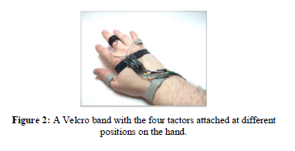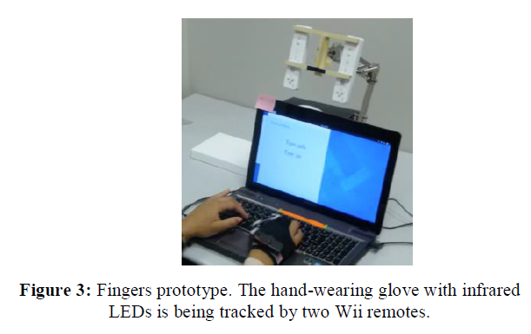

【TODO】